HAMPSHIRE SCHOOL GAMES
PRIMARY PERSONAL BEST CHALLENGES
SPRING TERM – WEEK 7 (1ST – 5TH MARCH))

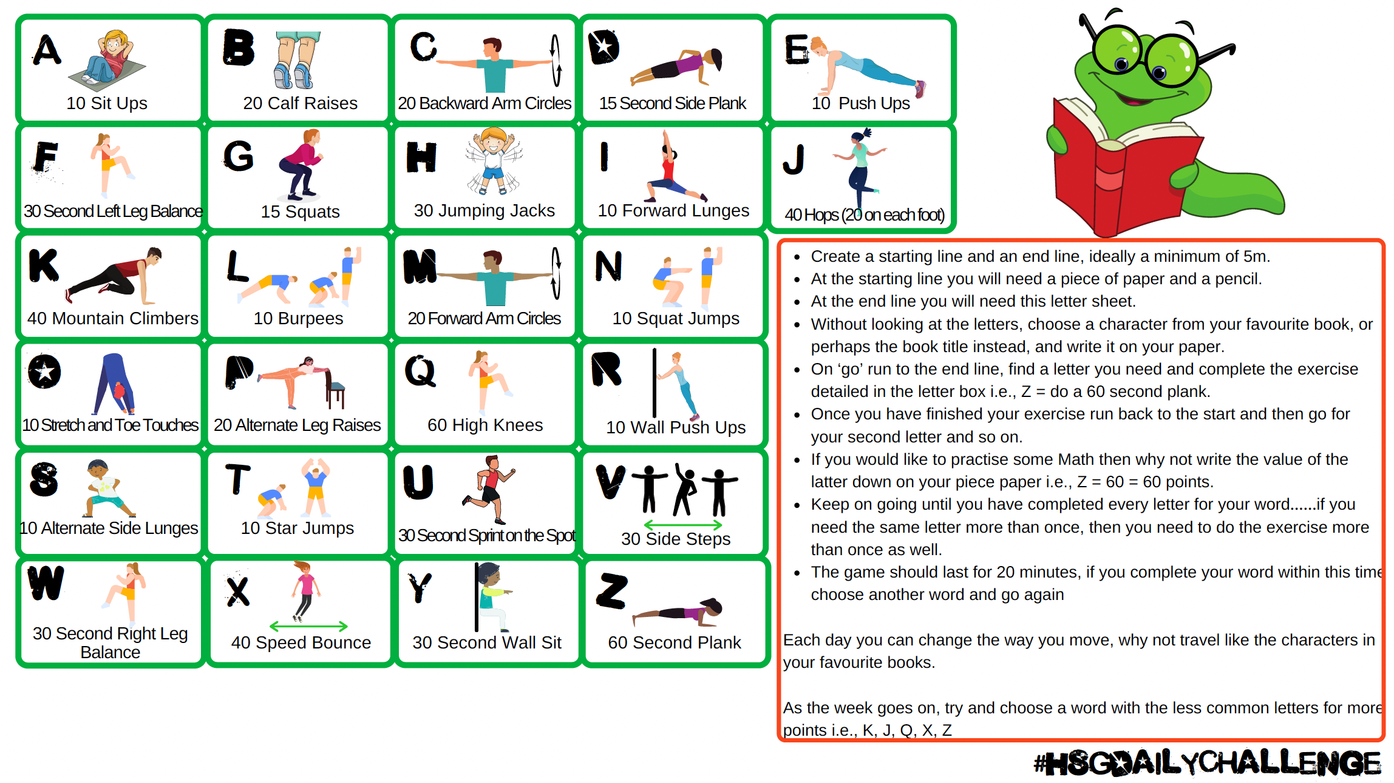

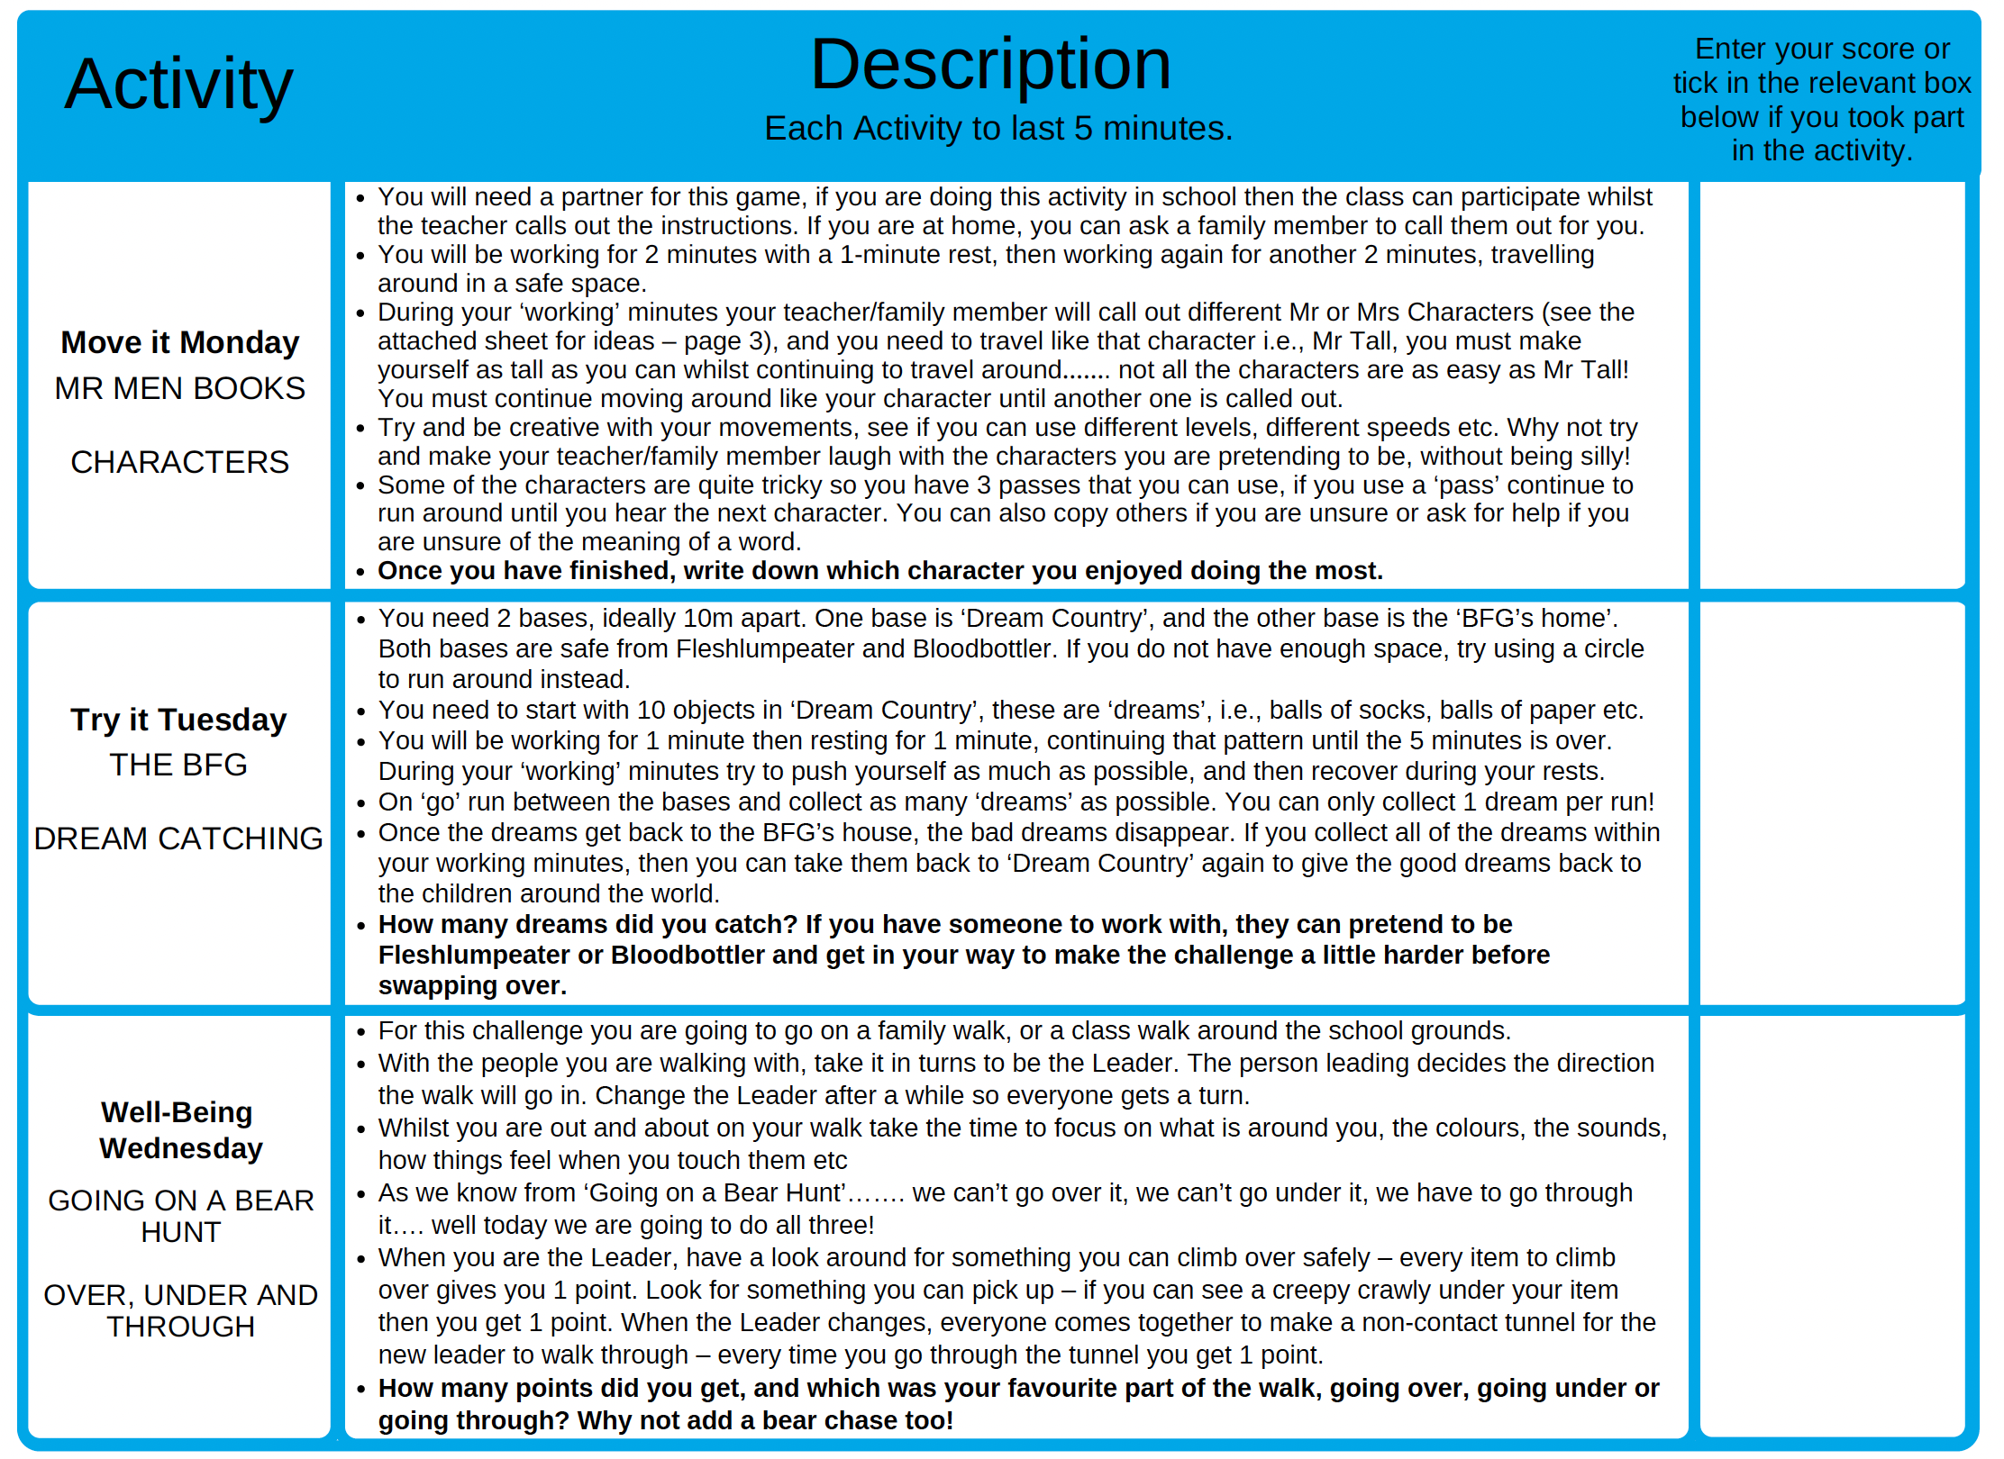

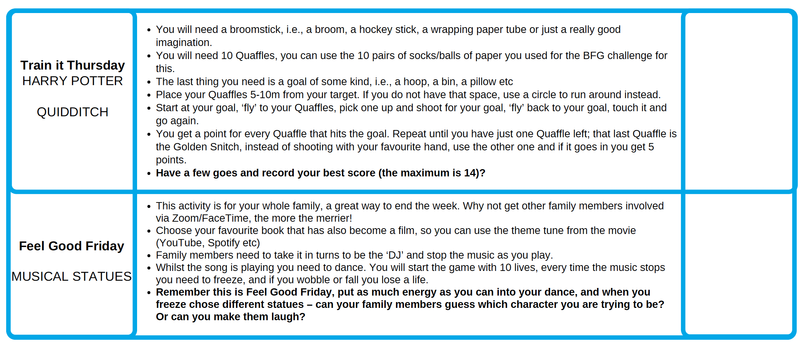

Send your completed sheet, or photo of you doing the activities to your teacher or your School Games Organiser (SGO) Holly.Shirley@mountbatten.hants.sch.uk.
Twitter: @SGOTest @HampshireSGO Facebook: @TestValley SchoolGames @HampshireSGO

please SEE the list of Mr Men and Little Miss
Characters on the next sheet

